Build an artificial neural network by implementing the backpropagation algorithm and test the same using the appropriate datasets.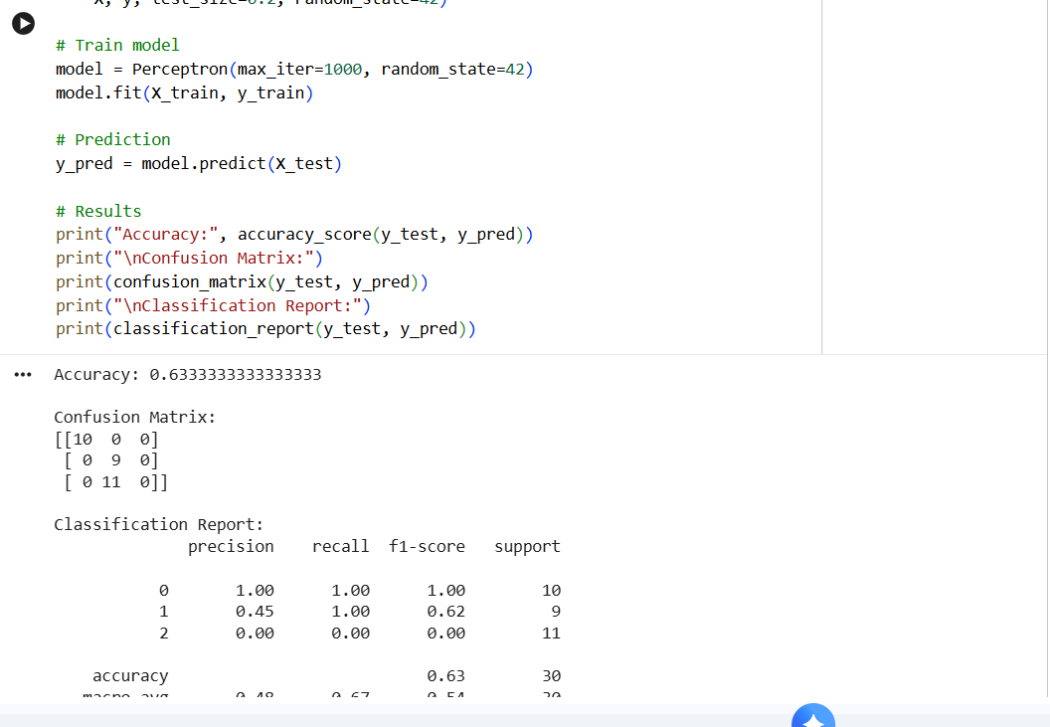

Implement perceptron based IRIS classification
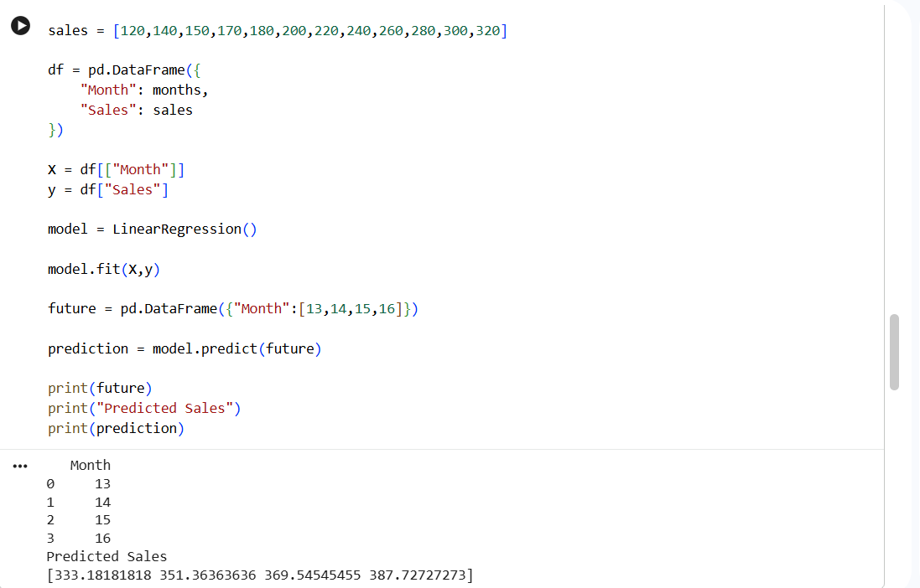
Implement future sales prediction using suitable machine learning algorithm
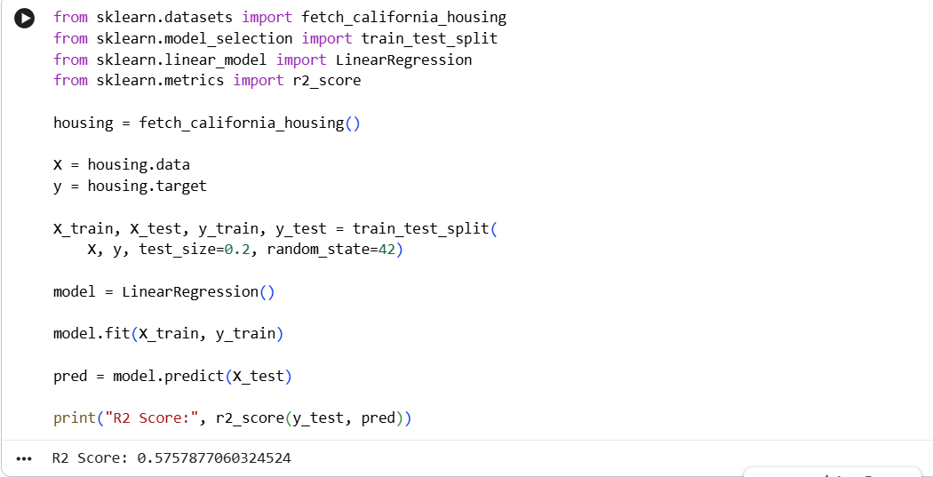

Implement house price prediction using a appropriate machine learning algorithm
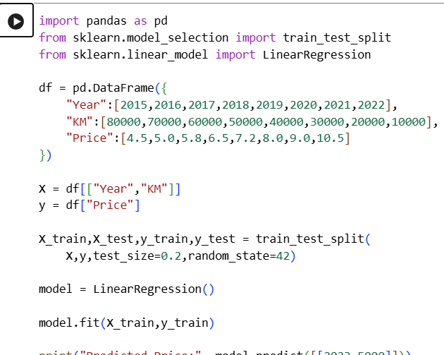

Implement the car price prediction model using python
